**Experiment No:** 05

**Experiment Name:** Implementation of FIFO Page Replacement Algorithm

**Aim and Objectives:** Learn about FIFO page replacement algorithm. Implement FIFO page replacement algorithm by using c program. And testing the program different input and find output .

**FIFO page replacement algorithm:**

It is one of the simplest page replacement algorithm. The oldest page, which has spent the longest time in memory is chosen and replaced. This algorithm is implemented with the help of FIFO queue to hold the pages in memory. A page is inserted at the rear end of the queue and is replaced at the front of the queue.

**Source Code:**

#include<stdio.h>

int main()

{

int i,j,n,no,k,avail=0,count=0,value[50],frame[10];

printf("\n Enter the number of pages ");

scanf("%d",&n);

printf("\n Enter the pages :\n");

for(i=1; i<=n; i++)

scanf("%d",&value[i]);

printf("\n Enter the number of frame : ");

scanf("%d",&no);

for(i=0; i<no; i++)

frame[i]= -1;

j=0;

printf("Ref string\t page frames\n");

for(i=1; i<=n; i++)

{

printf("%d\t",value[i]);

avail=0;

for(k=0; k<no; k++)

if(frame[k]==value[i])

avail=1;

if (avail==0)

{

frame[j]=value[i];

j=(j+1)%no;

count++;

for(k=0; k<no; k++)

printf("%d\t",frame[k]);

}

printf("\n");

}

printf("\nPage Fault Is %d\n",count);

return 0;

}

**Output:**

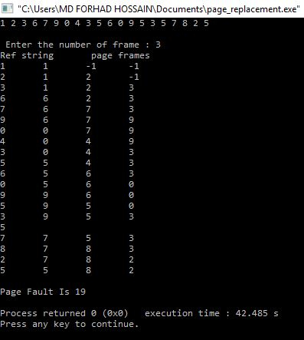

**Conclusion:**

After doing this labreport we learn about FIFO page replacement algorithm. We also learn how to implement FIFO page replacement by using C program And testing the program different input and find output.